Press Release
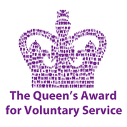
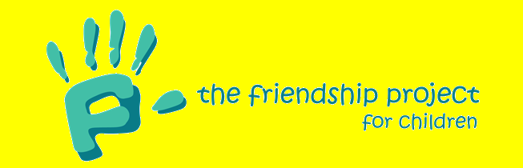

Emergency Funding Application Success
The Friendship Project for Children is pleased to announce success with a recent funding application and grant to help us continue our work in the community.

Richard Barrett, Fundraising Trustee, “We are pleased to have received two important grants. Firstly £7,500 from the Warwickshire Police and Crime Commissioner to help fund our continuing work in North Warwickshire and secondly £3,000 from the National Emergency Fund distributed by the Heart of England Community Foundation. Like so many charities we have lost many of our usual opportunities for fundraising at pre-planned events and donations from businesses, but still have expenditure with our team working hard to keep in contact with children in the Project and their families. This latter money is to help us to adapt and maintain our services for the children we support during the Covid-19 crisis in Warwickshire”.

Richard also commented “Staff have taken part in the 2.6 Challenge to raise funds for the Project: walking and planting 26 plants, cycling 2.6 miles and exercising for 2.6 hours. Our Younger Friends have also been scooting and cycling 2.6 miles to raise funds for us during this difficult time. A local brother and sister were very keen to raise funds for a local charity and chose us as they would like to help children in need of support. They are going to cycle 350 lockdown miles during May https://www.justgiving.com/fundraising/gandscycling.

The Friendship Project for Children operates throughout Warwickshire with the primary aim of helping children in need of some extra support. All children aged between 6 and 16 are referred to the charity through children’s social services and are then matched with an ‘Older Friend’ who takes them out and spends time with them for a few hours each week. In the current situation when so many people are in need of social contact and continuity, it is especially important that these friendships continue.

Cheryll Rawbone, Chairman of the Friendship Project said, “Our volunteers are continuing to keep in touch with their Younger Friends. Volunteers have been making dens and sending colourful pictures of their creations to their Younger Friends to make their own. One inventive Younger Friend has sent her Older Friend her own homemade word search, quiz and colouring sheet. It is important for the children we help know their Older Friends are thinking of them, supporting them now and looking forward to seeing them after lockdown”.

“It is incredibly rewarding being an Older Friend. It is important to keep in touch during lockdown so that my Younger Friend knows that I am here for him and won’t let him down”. LS, Volunteer

Since the charity started in 1986 it has supported over 1500 local children. The outstanding work of volunteers makes a huge difference within their community. There are many social reasons why children are in need of this kind of support, but experience has shown that a weekly visit by someone who cares makes a significant difference. The visit could be doing something as simple as a walking a dog or having a hot chocolate together; but could also include activities which the child would otherwise not get to experience, such as tenpin bowling, ice skating or horse riding.

For more information on The Friendship Project, please visit: www.friendshipproject.co.uk, @FriendshipProj or call 0845 838 2098.

A den that a volunteer made and sent to her Younger Friend for inspiration to make her own. A Younger Friend scooting 2.6 miles for the 2.6 Challenge.
